

SMART WATER DISTRIBUTION MONITORING USING GRAPH-BASED NETWORK ANALYSIS
A CAPSTONE PROJECT REPORT
Submitted in partial fulfilment of the requirements for the course
CSA0306 -DATA STRUCTURE
Submitted by
SANKAR R(192525131)
JEEVESH G (192511440)
GAUTHAM G (192524371)
PUGAZHARASAN K(192511341)
KANISH KUMAR V (192524361)
KARTHI M E(192521175)
to the award of the degree of

BACHELOR OF ENGINEERING / BACHELOR OF TECHNOLOGY IN
Computer Science And Engineering
Under the Guidance of
DR. Uma Priyadarsini P.S
SAVEETHA SCHOOL OF ENGINEERING
SAVEETHA INSTITUTE OF MEDICAL AND TECHNICAL SCIENCES
CHENNAI – 602105
SEPTEMBER 2026

BONAFIDE CERTIFICATE

This is to certify that the Capstone Project entitled “SMART WATER DISTRIBUTIONMONITORING USING GRAPH-BASED NETWORK ANALYSIS”has been successfully carried out by Gautham G,Kanish Kumar V,Sankar R,Jeevesh G,Karthi M.E,Pugazharasan K under supervision and guidance of Dr. Uma Priyadarsini P.S

The project is submitted in partial fulfilment of the academic requirements for the current semester of the B.Tech programme at Saveetha Institute of Medical and Technical Sciences, Chennai, and demonstrates the practical application of Computer Networks concepts in campus network monitoring, security management, and performance analysis.

Guided By
DR Uma Priyadarsini P.S
Head of Department
CSE
SIMATS

Program Director
DR Ruby Elizabeth J
Head of Department
CSE
SIMATS

DECLARATION

We hereby declare that the project work entitled “Smart Water Distribution Monitoring Using Graph Based Network Analysis” is an original academic work carried out as part of the course CSA0309-Data Structure.This project focuses on representing the water distribution system as a graph, where water sources, storage tanks, junctions, and consumer areas are represented as nodes, while pipelines are represented as edges. The proposed system helps in analyzing network connectivity, identifying critical nodes and pipelines, monitoring water flow, and detecting possible distribution problems.
We declare that the work presented in this report has been carried out with sincere effort and under appropriate academic guidance. The information, concepts, analysis, and implementation included in this project have been prepared for educational purposes. We have made every effort to ensure that the work is accurate, organized, and relevant to the objectives of the project.
We further declare that this project has not been submitted previously, either in whole or in part, to any other institution or university for the award of any degree, diploma, or academic qualification. We take full responsibility for the authenticity and originality of the work presented in this report.

Place: Chennai
Date: September 2026
Student Signatures:
1. Sankar R
2. Kanish Kumar V
3. Gautham G
- Jeevesh G
- Karthi M E
- Pugazharasan K

INDIVIDUAL CONTRIBUTION STATEMENT
Student / Register No. | Primary Responsibility | Design & Development | Testing & Analysis | Report Contribution | Approx. %
Gautham G  192524371 | Module 1 – Water Network Modeling | Creates the water network as a graph.  Nodes represent water points.  Edges represent pipelines.  Helps monitor water flow. | Network connections are checked.  Flow values are verified.  Problems are identified. | Module 1-Explains the network structure.  Shows the graph-based model.  Presents testing results.  . | 20%
Sankar R | Module 2 – Sensor Data Collection | Sensors collect water data.  Flow and pressure are monitored.  Data is stored for analysis. | Sensor readings are checked.  Abnormal values are identified.  Data accuracy is verified. | Module 2-Explains sensor data collection.  Shows collected data.  Presents analysis results. | 20%
Kanish Kumar V  192524361 | Module 3 – Graph Based Network Analysis | Represents the water system as a graph.  Analyzes nodes and pipelines.  Finds important network points. | Network connections are tested.  Critical points are identified.  Results are checked for accuracy. | Module 3-Explains graph-based analysis.  Shows network analysis results.  Helps identify water distribution problems. | 20%
Pugazharasan K  192511341 | Module 4-Leak Detection &Fault Identification | Monitors water flow and pressure.  Detects unusual changes in readings.  Identifies possible leaks and faults. | Tests normal and abnormal readings.  Checks detected leaks.  Verifies fault identification. | Explains leak detection methods.  Shows detected faults.  Presents the analysis results. | 15%
Karthi M .E  192521175 | Module 5-Smart Monitoring Dashboard | Displays water network data.  Shows flow and pressure values.  Provides real-time monitoring. | Dashboard values are checked.  Alerts are tested.  Display accuracy is verified. | Shows the monitoring dashboard.  Presents real-time data.  Displays alerts and network status. | 10%
Jeevesh G  192511440 | Module 6-Optimization&Decision Support | Analyzes network performance.  Finds better water flow paths.  Supports quick decisions. | Tests different network conditions.  Compares the results.  Checks the best solution. | Explains optimization methods.  Shows improved network performance.  Supports efficient water management. | 15%

ABSTRACT

The Smart Water Distribution Monitoring Using Graph-Based Network Analysis system is developed to provide an efficient and intelligent method for monitoring water distribution networks. The system represents the water network as a graph, where junctions, tanks, pumps, and supply points are treated as nodes and pipelines are represented as edges. Sensors are used to collect important data such as water flow, pressure, and water level. The collected data is analyzed to identify abnormal conditions, possible leaks, pipeline faults, pressure changes, and critical network points. A smart monitoring dashboard provides a simple view of the network status, sensor readings, and alerts in real time. Graph-based analysis helps understand network connectivity and supports better water-flow management. The optimization module analyzes the network and helps select suitable solutions for efficient water distribution. The system can reduce water wastage, improve fault detection, support quick decision-making, and increase the overall reliability of the water supply system. Thus, the proposed system provides a simple and effective approach for real-time monitoring, fault identification, network analysis, and optimization of modern water distribution networks.

Keywords: Smart Water Distribution, Graph-Based Network, Sensor Data Collection, Water Flow Monitoring, Leak Detection, Fault Identification, Real-Time Dashboard, Network Optimization, Decision Support, Water Management.

TABLE OF CONTENTS
Chapter | Title | Approx. Page
1 | Introduction, Need and Problem Definition | 11
2 | CHAPTER 2 - WATER DISTRIBUTION NETWORK FUNDAMENTALS | 10
3 | CHAPTER 3 SYSTEM REQUIREMENTS AND ARCHITECTURE | 12
4 | CHAPTER 4 –MODULE 1: WATER NETWORK MODELING | 14
5 | CHAPTER 5-MODULE 2: SENSOR DATA COLLECTION | 18
6 | CHAPTER 6-MODULE 3: GRAPH-BASED NETWORK ANALYSIS | 19
7 | CHAPTER 7 – MODULE 4: LEAK DETECTION & FAULT IDENTIFICATION | 21
8 | CHAPTER 8 - MODULE 5: SMART MONITORING DASHBOARD | 22
9 | CHAPTER 9 – MODULE 6: OPTIMIZATION & DECISION SUPPORT | 23
10 | CHAPTER 10 – IMPLEMENTATION, TESTING AND RESULTS | 24–26
11 | CHAPTER 11-ADVANTAGES, LIMITATIONS AND FUTURE SCOPE
12 | CHAPTER 12 –CONCLUSION

LIST OF FIGURES

Figure No. | Figure Title
Fig. 4.5 | MODULE 1: WATER NETWORK MODELING
Fig. 5.5 | MODULE 2: SENSOR DATA COLLECTION
Fig. 6.7 | MODULE 3: GRAPH-BASED NETWORK ANALYSIS
Fig. 7.6 | MODULE 4: LEAK DETECTION & FAULT IDENTIFICATION
Fig. 8.5 | MODULE 5: SMART MONITORING DASHBOARD
Fig.9.5 | MODULE 6: OPTIMIZATION & DECISION SUPPORT

LIST OF TABLES

Table No. | Table Title
Table 1.6 | Module Structure
Table 2.2 | Network Components
Table 2.5 | Water Network Parameters
Table 3.1 | Functional Requirements
Table 5.4 | Sensor Data Example
Table 7.5 | Alert Classification
Table 9.4 | Maintenance Priority
Table 10.2 | Testing

LIST OF ABBREVIATIONS

Abbreviation | Meaning
No. | Abbreviation | Full Form
1 | WDS | Water Distribution System
2 | WDM | Water Distribution Monitoring
3 | GBA | Graph-Based Analysis
4 | IoT | Internet of Things
5 | GIS | Geographic Information System
6 | AI | Artificial Intelligence
7 | ML | Machine Learning
8 | GUI | Graphical User Interface
9 | UI | User Interface
10 | API | Application Programming Interface
11 | SQL | Structured Query Language
12 | KPI | Key Performance Indicator
13 | RT | Real-Time
14 | P | Pressure
15 | FR | Flow Rate

CHAPTER 1
INTRODUCTION, NEED AND PROBLEM DEFINITION
1.1 Background
Water distribution systems consist of interconnected pipes, tanks, pumps, valves and consumer points. Monitoring these components is important to maintain continuous water supply and reduce water losses.
1.2 Need for the Project
- Detect water leakage quickly.
- Monitor pressure and flow conditions.
- Identify faulty network sections.
- Visualize the complete water distribution network.
- Reduce water wastage.
- Support better maintenance decisions.
1.3 Problem Statement
Traditional water distribution monitoring mainly depends on manual inspection and separate measurements. This can make it difficult to identify leaks, pressure abnormalities and network faults quickly. The proposed system uses graph-based network analysis to represent the water network as connected nodes and edges and monitor its condition centrally.
1.4 Objectives
- Model the water distribution system as a graph.
- Collect pressure and flow sensor data.
- Analyze connections between network components.
- Detect possible leaks and faults.
- Display network status through a dashboard.
- Provide optimization and maintenance recommendations.
1.5 Scope
The system can monitor a simulated or real water distribution network containing pipes, junctions, tanks, pumps, valves and sensors. The prototype can initially use simulated sensor data and can later be connected to IoT sensors

1.6 Module Structure

Module | Purpose | Main Output
Module 1 – Water Network Modeling | Represent the water distribution system using nodes, pipes, tanks, pumps, and valves as a graph. | Water network topology and network model.
Module 2 – Sensor Data Collection | Collect pressure, flow rate, water level, pump, and valve status from different locations. | Real-time sensor readings and water parameters.
Module 3 – Graph-Based Network Analysis | Analyze network connectivity, critical nodes, critical pipes, and shortest paths using graph techniques. | Network analysis results and critical component information.
Module 4 – Leak Detection & Fault Identification | Identify abnormal flow, pressure changes, leaks, and equipment faults in the network. | Leak/fault alerts and fault location information.
Module 5 – Smart Monitoring Dashboard | Display network topology, sensor data, alerts, and overall network condition in a single interface. | Real-time monitoring dashboard and network status.
Module 6 – Optimization & Decision Support | Analyze network conditions and suggest suitable paths, maintenance priorities, and corrective actions. | Optimization results and recommended maintenance actions.

CHAPTER 2
WATER DISTRIBUTION NETWORK FUNDAMENTALS
2.1 Water Distribution System
A water distribution system transfers water from sources and storage facilities to consumers through a network of pipes and control devices.
2.2 Network Components
Component | Function
Source | Supplies water
Tank | Stores water
Pump | Increases water pressure
Pipe | Carries water
Junction | Connects multiple pipes
Valve | Controls water flow
Sensor | Measures network conditions
Consumer | Represents water demand

2.3 Graph Theory Fundamentals
A water network can be represented as a graph:
G = (V, E)
Where:
V = nodes such as junctions, tanks and pumps.
E = edges representing connecting pipes.

2.4 Graph Representation
Example:
Source → Junction 1 → Junction 2 → Consumer
Each node can store pressure, demand and sensor information, while each edge can store pipe length, diameter, flow and status.

2.5 Water Network Parameters
Parameter | Description | Unit / Example
Pressure | Measures the water pressure at different nodes in the network. | bar / kPa
Flow Rate | Indicates the amount of water flowing through a pipe. | L/s or m³/h
Water Level | Shows the water level in tanks or reservoirs. | m or %
Pipe Length | Represents the distance between two connected nodes. | metres (m)
Pipe Diameter | Defines the size of the pipe carrying water. | mm
Water Demand | Amount of water required by a particular area or node. | L/s
Pump Status | Indicates whether a pump is ON or OFF. | ON / OFF
Valve Status | Shows whether a valve is open, closed, or partially open. | Open / Closed
Node Connectivity | Represents the connection between junctions, tanks, pumps, and pipes. | Graph-based
Leak Status | Indicates whether abnormal water loss is detected in a pipe or node. | Normal / Leak

CHAPTER 3

SYSTEM REQUIREMENTS AND ARCHITECTURE

3.1 Functional Requirements

Requirement | Expected Behaviour
Network Modeling | Create nodes and pipe connections
Sensor Monitoring | Collect pressure and flow data
Graph Analysis | Analyze network connectivity
Leak Detection | Identify abnormal flow/pressure
Fault Detection | Identify failed components
Dashboard | Display live network status
Optimization | Suggest suitable actions
Reports | Generate monitoring reports

3.2 Non-Functional Requirements
- Simple user interface
- Fast response
- Scalable architecture
- Reliable data processing
- Easy visualization
- Modular design

3.3 System Architecture
Water Sources / Sensors
↓
Sensor Data Collection
↓
Water Network Graph Model
↓
Graph-Based Analysis
↓
Leak & Fault Detection
↓
Smart Monitoring Dashboard
↓
Optimization & Decision Support

3.4 Data Model
Each network node can contain:
- Node ID
- Node type
- Location
- Pressure
- Flow rate
- Water demand
- Status
- Timestamp
Each pipe can contain:
- Pipe ID
- Start node
- End node
- Length
- Diameter
- Flow rate
- Pressure
- Pipe status

CHAPTER 4 –

MODULE 1: WATER NETWORK MODELING

4.1 Purpose
This module creates a digital representation of the water distribution system using nodes and connecting pipes.

4.2 Main Functions
- Create network nodes.
- Define pipe connections.
- Store pipe properties.
- Represent sources, tanks and consumers.
- Display the network graph.
- Maintain node and pipe status.

4.3 Input
- Node information
- Pipe information
- Network connections
- Component properties

4.4 Processing
The system converts the water distribution layout into a graph structure using nodes and edges.

4.5 Output
- Water network graph
- Node details
- Pipe details
- Network connectivity information

FIG 1:
- 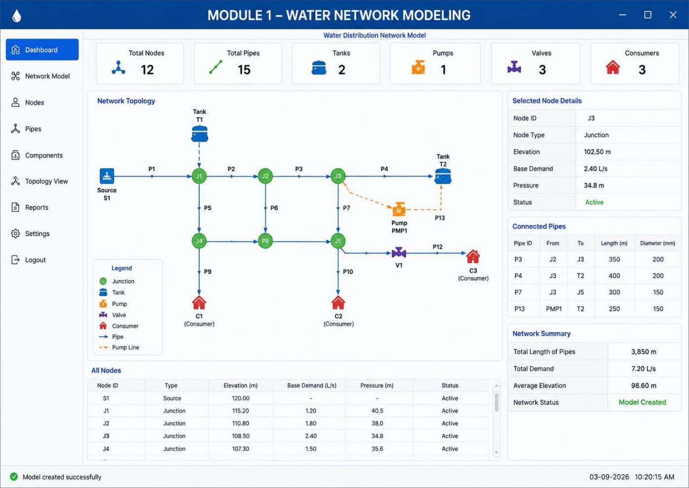

CHAPTER 5

MODULE 2: SENSOR DATA COLLECTION

5.1 Purpose
This module collects measurements from sensors installed at important points in the water network.

5.2 Sensors
- Pressure sensor
- Flow sensor
- Water-level sensor
- Valve-status sensor
- Pump-status sensor

5.3 Data Processing
Sensor readings are collected, timestamped and associated with their corresponding graph nodes or pipes:
5.4 Sensor Data Example
Sensor | Parameter | Value
S01 | Pressure | 42 PSI
S02 | Flow | 75 L/min
S03 | Tank Level | 82%
S04 | Pressure | 28 PSI

5.5 Output
The collected sensor information is passed to the graph analysis and fault detection modules.
FIG 2:
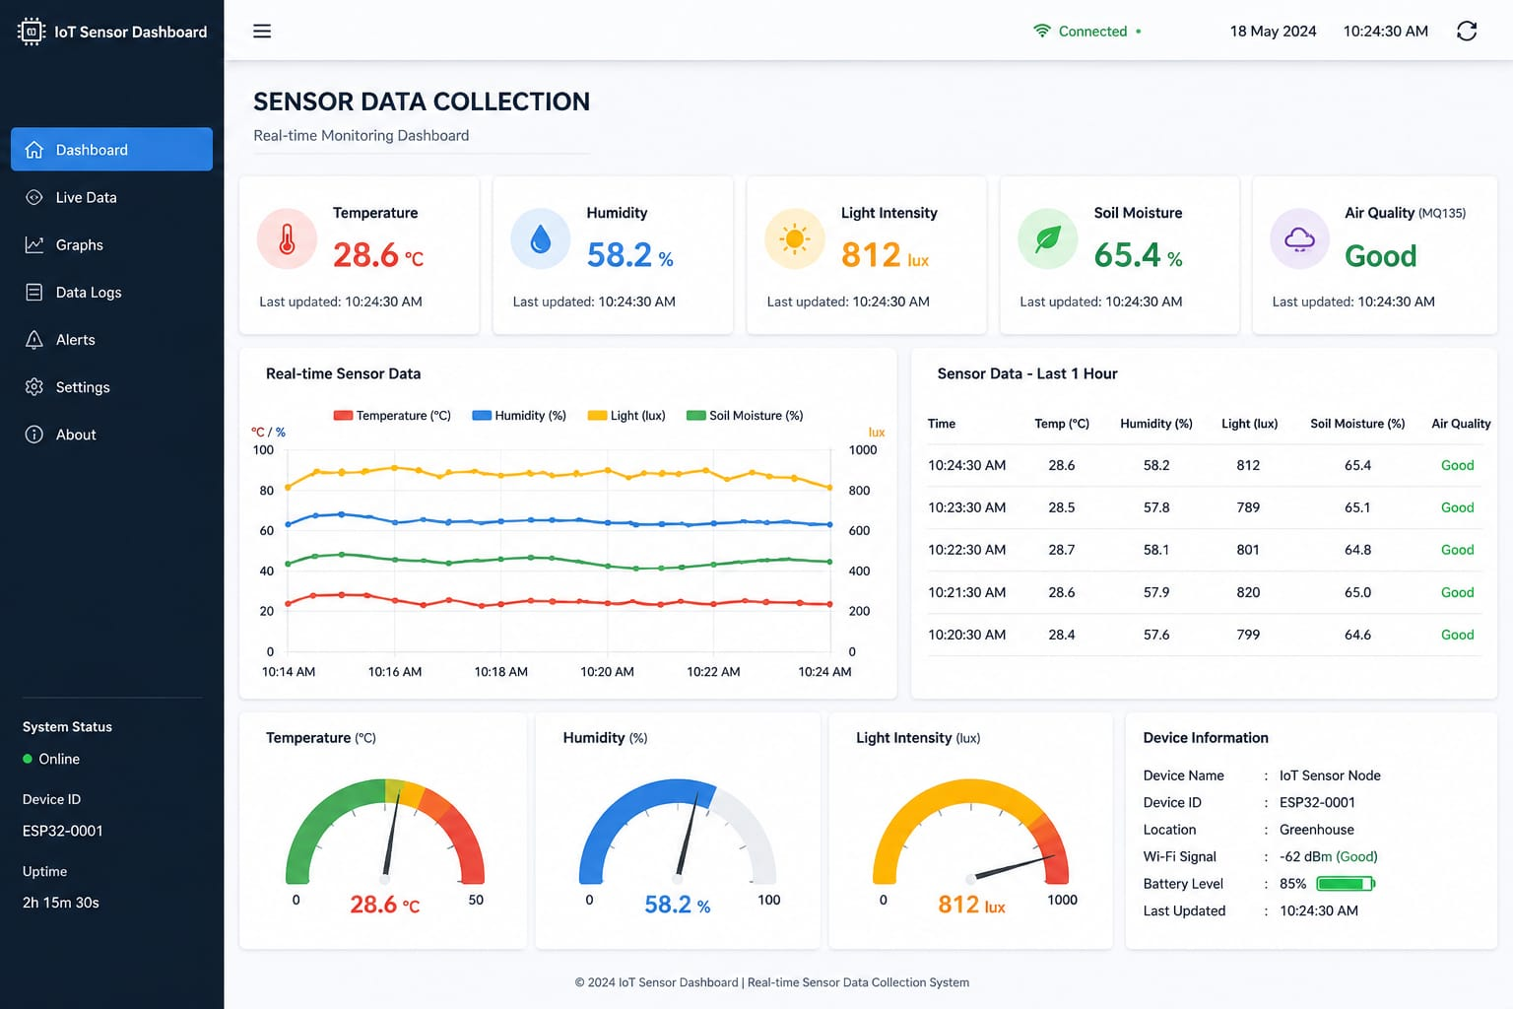

CHAPTER 6

MODULE 3: GRAPH-BASED NETWORK ANALYSIS

6.1 Purpose
This is the core module of the project. It analyzes the water network using graph theory.

6.2 Graph Construction
- Junctions → Nodes
- Pipes → Edges
- Pipe length → Edge weight
- Flow → Edge property
- Pressure → Node property

6.3 Network Connectivity Analysis
The system checks whether all important nodes remain connected to the water source.

6.4 Path Analysis
Graph algorithms can identify paths between the source and consumer nodes.

6.5 Important Graph Analysis
- Node degree
- Connectivity
- Shortest path
- Critical nodes
- Critical pipes
- Fault domains

6.6 Critical Node Identification
A node connected to many important sections can have a major effect on the network. Such nodes receive higher monitoring priority.

6.7 Output
- Network connectivity
- Critical nodes
- Critical pipes
- Possible affected areas
- Network health status
FIG 3:
- 

CHAPTER 7–
MODULE 4: LEAK DETECTION & FAULT IDENTIFICATION

7.1 Purpose
This module identifies abnormal conditions using sensor readings and graph relationships.

7.2 Leak Detection
A possible leak can be identified when the measured input flow is significantly higher than the expected downstream consumption.
- Possible Leak = Input Flow − Expected Output Flow

7.3 Pressure-Based Detection
A sudden pressure drop can indicate:
- Pipe leakage
- Pipe damage
- Valve problem
- Pump failure

7.4 Fault Identification
The system checks:
- Pipe failure
- Sensor failure
- Pump failure
- Valve failure
- Pressure abnormality
- Flow abnormality

7.5 Alert Classification
Condition | Severity
Small pressure variation | Low
Abnormal flow | Medium
Suspected leakage | High
Major pipe failure | Critical
Pump failure affecting network | Critical

7.6 Output
- Leak location
- Fault type
- Affected network section
- Severity
- Alert message
FIG 4:
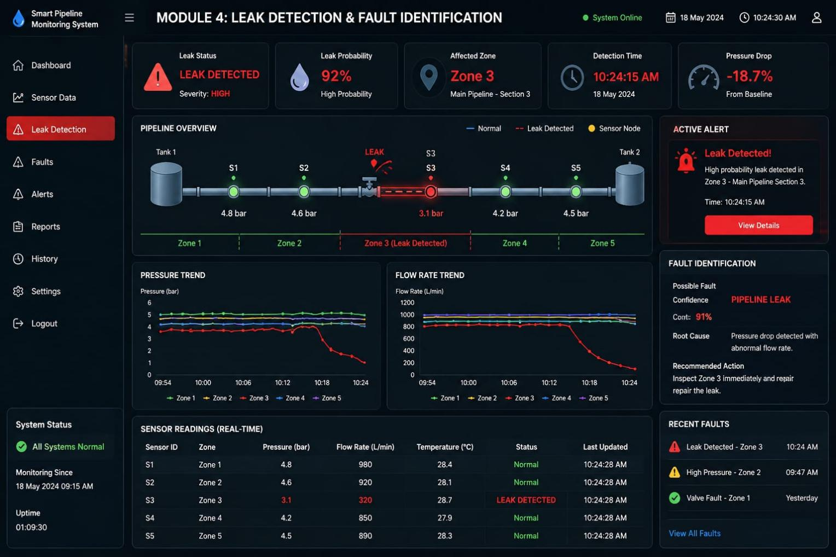

CHAPTER 8

MODULE 5: SMART MONITORING DASHBOARD

8.1 Purpose
The dashboard provides a centralized view of the complete water distribution network.

8.2 Dashboard KPIs
- Total nodes
- Total pipes
- Active sensors
- Normal nodes
- Faulty nodes
- Detected leaks
- Average pressure
- Total flow
- Water usage

8.3 Network Visualization
The dashboard displays the graph with:
- Water sources
- Junctions
- Pipes
- Sensors
- Pumps
- Valves
- Fault locations

8.4 Graph Status
Nodes and pipes can be represented using different status indicators:
Normal → Warning → Fault

8.5 Dashboard Output
The administrator can quickly understand:
- Current network condition
- Leakage locations
- Pressure problems
- Faulty components
- Water demand
- Critical network sections

FIG 5:
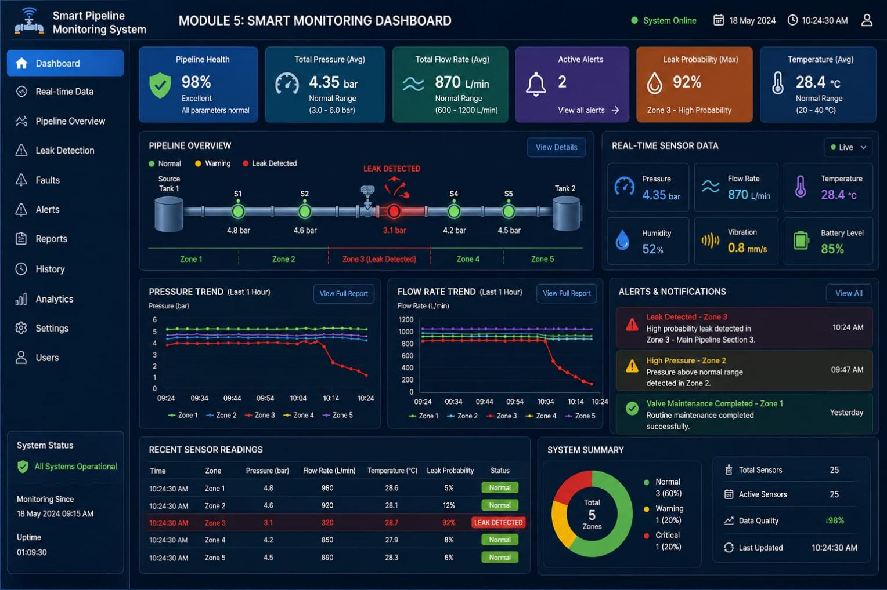

CHAPTER 9 – MODULE 6: OPTIMIZATION & DECISION SUPPORT

9.1 Purpose
This module uses network analysis results to support maintenance and operational decisions.

9.2 Optimization Functions
- Identify the shortest supply path.
- Prioritize critical pipe maintenance.
- Reduce unnecessary water loss.
- Balance water pressure.
- Identify high-demand areas.
- Recommend valve/pump actions.

9.3 Decision Support
The system can provide recommendations such as:
Detected leak → Identify affected pipe → Estimate impact → Prioritize repair

9.4 Maintenance Priority
Condition | Priority
Normal | Low
Pressure variation | Medium
Suspected leak | High
Critical pipe failure | Very High

9.5 Output
- Maintenance priority
- Recommended action
- Affected area
- Critical network components
- Optimization suggestions

FIG 6 :

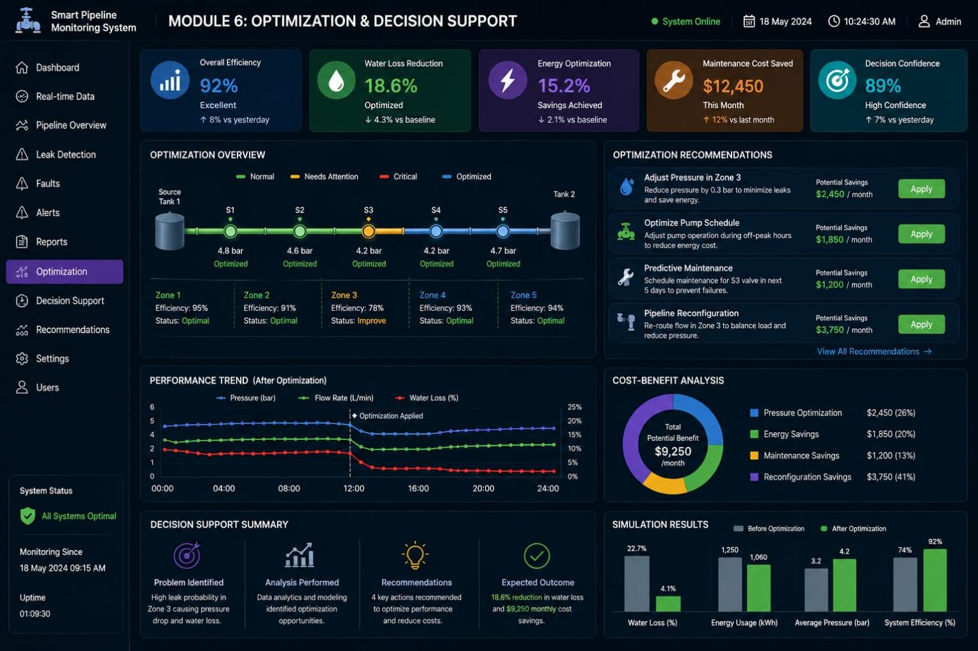

CHAPTER 10 – IMPLEMENTATION, TESTING AND RESULTS

10.1 Software Implementation
A suitable implementation can use:
- Python – Main programming
- NetworkX – Graph-based network analysis
- Pandas – Sensor data processing
- Matplotlib – Graph visualization
- Tkinter – Monitoring dashboard
- SQLite – Data storage

10.2 Testing
Test ID | Test Condition | Expected Result
WN-01 | Load network | Network graph displayed
WN-02 | Add node | Node appears in graph
WN-03 | Add pipe | Connection appears
SD-01 | Receive sensor value | Data displayed
LD-01 | Abnormal flow | Leak alert generated
FD-01 | Pipe failure | Fault identified
GD-01 | Analyze graph | Critical nodes identified
DB-01 | Open dashboard | KPIs and graph displayed
OP-01 | Run optimization | Recommendation generated

10.3 Result Interpretation
The system should successfully convert water-network data into a graph representation, process sensor measurements, identify abnormal conditions and display the network status through a centralized dashboard.

CHAPTER 11 – ADVANTAGES, LIMITATIONS AND FUTURE SCOPE

11.1 Advantages
- Centralized water-network monitoring.
- Faster leak identification.
- Graph-based visualization.
- Better understanding of network connectivity.
- Reduced water wastage.
- Supports preventive maintenance.
- Easy-to-understand dashboard.
- Can be expanded with IoT sensors.

11.2 Limitations
- Prototype may initially use simulated sensor data.
- Real sensor integration requires hardware.
- Detection accuracy depends on sensor quality.
- Network conditions can change dynamically.
- Large networks require efficient graph processing.

11.3 Future Scope
- IoT-based real-time sensor integration.
- Cloud-based monitoring.
- AI-based leak prediction.
- Mobile application.
- Automatic valve control.
- Real-time alerts through SMS/email.
- Digital twin of the water network.
- Advanced predictive maintenance.

CHAPTER 12 – CONCLUSION
The Smart Water Distribution Monitoring Using Graph-Based Network Analysis project provides an effective approach for monitoring and managing modern water distribution networks. The system represents the water distribution network as a graph, where junctions, tanks, pumps, valves, and consumer points are represented as nodes, while the connecting pipes are represented as edges. This graph-based representation makes it easier to understand the structure and connectivity of the entire water network.
The system collects important water network parameters such as pressure, flow rate, water level, pump status, valve status, and water demand. These parameters help in continuously observing the condition of the network. The collected sensor data can be analyzed to identify abnormal changes and provide information about the current operating condition of the system.
Graph-based analysis helps identify critical nodes, important pipes, network connectivity, and possible fault locations. By analyzing the relationship between different nodes and pipes, the system can determine areas that require greater attention. This improves the understanding of how a fault or leak in one part of the network can affect other connected areas.
The Leak Detection and Fault Identification module improves network reliability by detecting unusual flow differences, pressure drops, and equipment abnormalities. When an abnormal condition is identified, the system generates alerts so that the responsible person can take suitable corrective action. This can help reduce unnecessary water loss and improve the reliability of water supply.
The Smart Monitoring Dashboard provides a simple and centralized interface for viewing network topology, sensor readings, alerts, water flow, pressure levels, and overall network status. Instead of checking individual sensors manually, the operator can observe important information from a single dashboard. This supports faster monitoring and easier decision-making.
The Optimization and Decision Support module further improves the system by providing recommendations such as identifying high-priority pipes, selecting suitable supply paths, balancing pressure, and prioritizing maintenance activities. These recommendations can help reduce maintenance time, improve water distribution, and support efficient utilization of available resources.

Overall, the proposed system demonstrates how graph theory, sensor data, monitoring, fault detection, visualization, and optimization can be combined to develop a smart water distribution monitoring solution. The system provides a structured method for understanding network conditions and responding to problems at an early stage.
In the future, the system can be enhanced by integrating IoT-based sensors, cloud platforms, machine learning, real-time GIS maps, mobile notifications, and predictive leak detection. These improvements can make the system more intelligent and capable of predicting failures before they become major problems.
Thus, the project successfully demonstrates the importance of graph-based network analysis in developing a smart, reliable, efficient, and scalable water distribution monitoring system. It can serve as a foundation for future smart-city water management applications.

Keywords
Smart Water Distribution, Graph Theory, Network Analysis, IoT Sensors, Leak Detection, Fault Detection, Pressure Monitoring, Flow Monitoring, Water Management, Optimization, Smart Dashboard.

